

THE UNIVERSITY OF AZAD JAMMU AND KASHMIR, MUZAFFARABAD
Department of Software Engineering

Submitted to: | Engr. Sidra Rafique
Course Title: | Operating System
Course Code: | CS-2105
Session: | 2024-2028
Lab No: | 01
Roll No: | 2024-SE-15
Submitted By: | Shahzad Ahmed Awan
Submission date: | October 25, 2025

Table of Contents
Lab 01 – Task Manager Analysis 3
1. Objective 3
2. Background 3
3. Procedure 3
3.1 Opening the Task Manager 3
3.2 Processes Tab 4
3.3 Performance Tab 4
3.4 App History Tab 6
3.5 Startup Apps Tab 6
3.6 Users Tab 7
3.7 Details Tab 7
3.8 Services Tab 8
4. Analysis 8
5. Conclusion 9
6. Reflection 9

Table of Figures
Figure 1: Opening the Task Manager 3
Figure 2: Processes Tab Analysis 4
Figure 3: Performance tab Analysis - CPU Graph 5
Figure 4: Performance Tab Analysis - Memory Graph 5
Figure 5: App History Tab Analysis 6
Figure 6: Startup Apps Tab Analysis 6
Figure 7: User Tab Analysis 7
Figure 8: Details Tab Analysis 7
Figure 9: Services Tab Analysis 8

Lab 01 – Task Manager Analysis

1. Objective
The objective of this laboratory exercise is to examine and analyze the functionalities of the Windows Task Manager, focusing on its various tabs and their role in system monitoring and resource management. The lab aims to develop understanding of how Task Manager assists in managing applications, performance, and background processes in a Windows operating environment.

2. Background
The Task Manager is an essential system utility in Microsoft Windows designed to provide real-time information about the system’s performance and active processes. It allows users to monitor resource usage, terminate unresponsive programs, and manage startup applications and system services.
This lab involves a systematic inspection of each Task Manager tab to understand how Windows organizes process data, performance metrics, and service management interfaces.

3. Procedure

3.1 Opening the Task Manager
The Task Manager can be launched using several methods:
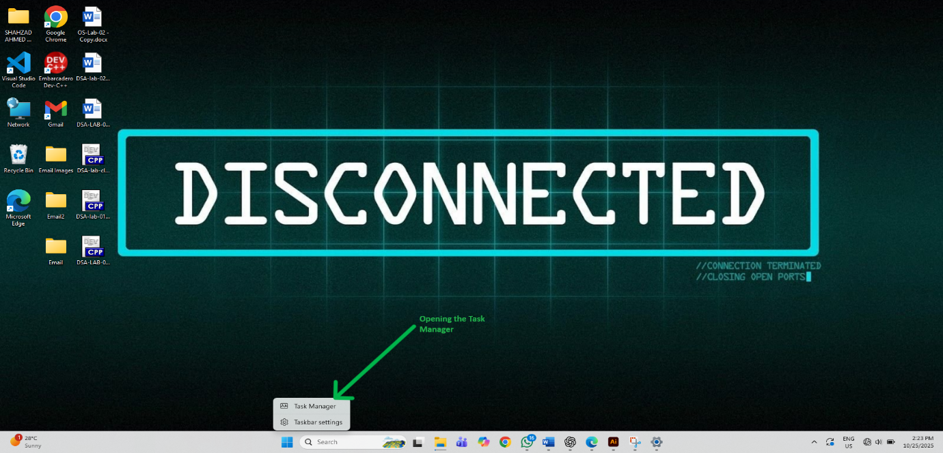
- Press Ctrl + Shift + Esc.
Figure 1: Opening the Task Manager
- Right-click the Start button and select Task Manager.
- Press Ctrl + Alt + Delete and choose Task Manager from the menu.
Upon opening, the simplified view appears by default. The More details option was selected to expand the interface into the full detailed view containing multiple tabs.

3.2 Processes Tab
The Processes tab lists all currently active applications and background processes. Each entry includes columns showing CPU, Memory, Disk, Network, and GPU utilization in real time.
During inspection, applications such as Microsoft Edge and File Explorer were visible under the Apps category, while numerous system processes appeared under Background processes. The tab also highlights total resource usage percentages at the top.
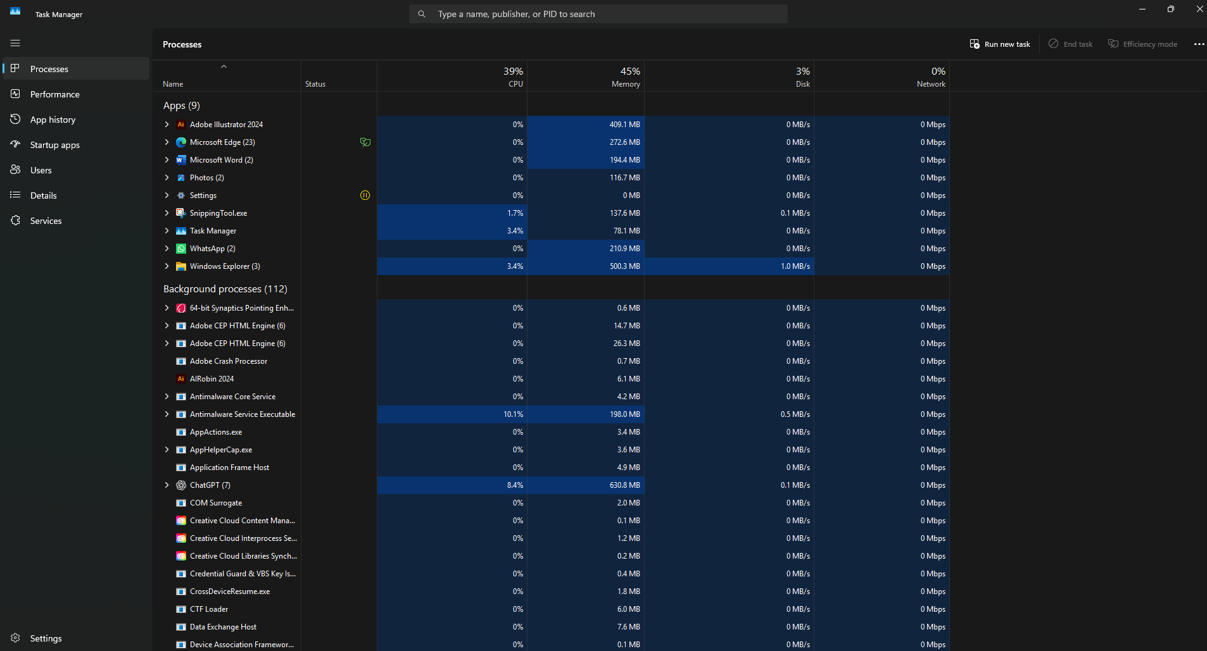
This view assists in identifying performance-intensive applications and provides an option to terminate unresponsive tasks through the End Task command.
Figure 2: Processes Tab Analysis

3.3 Performance Tab
The Performance tab presents graphical and numerical data for major hardware components, including CPU, Memory, Disk, Ethernet/Wi-Fi, and GPU.
The CPU section shows real-time utilization graphs, base speed, number of cores, logical processors, and system uptime. The memory section displays total, used, and available RAM, along with cache size and form factor. The disk and network sections illustrate data transfer rates and activity levels.
This tab serves as a central hub for evaluating system performance and diagnosing hardware or resource bottlenecks.
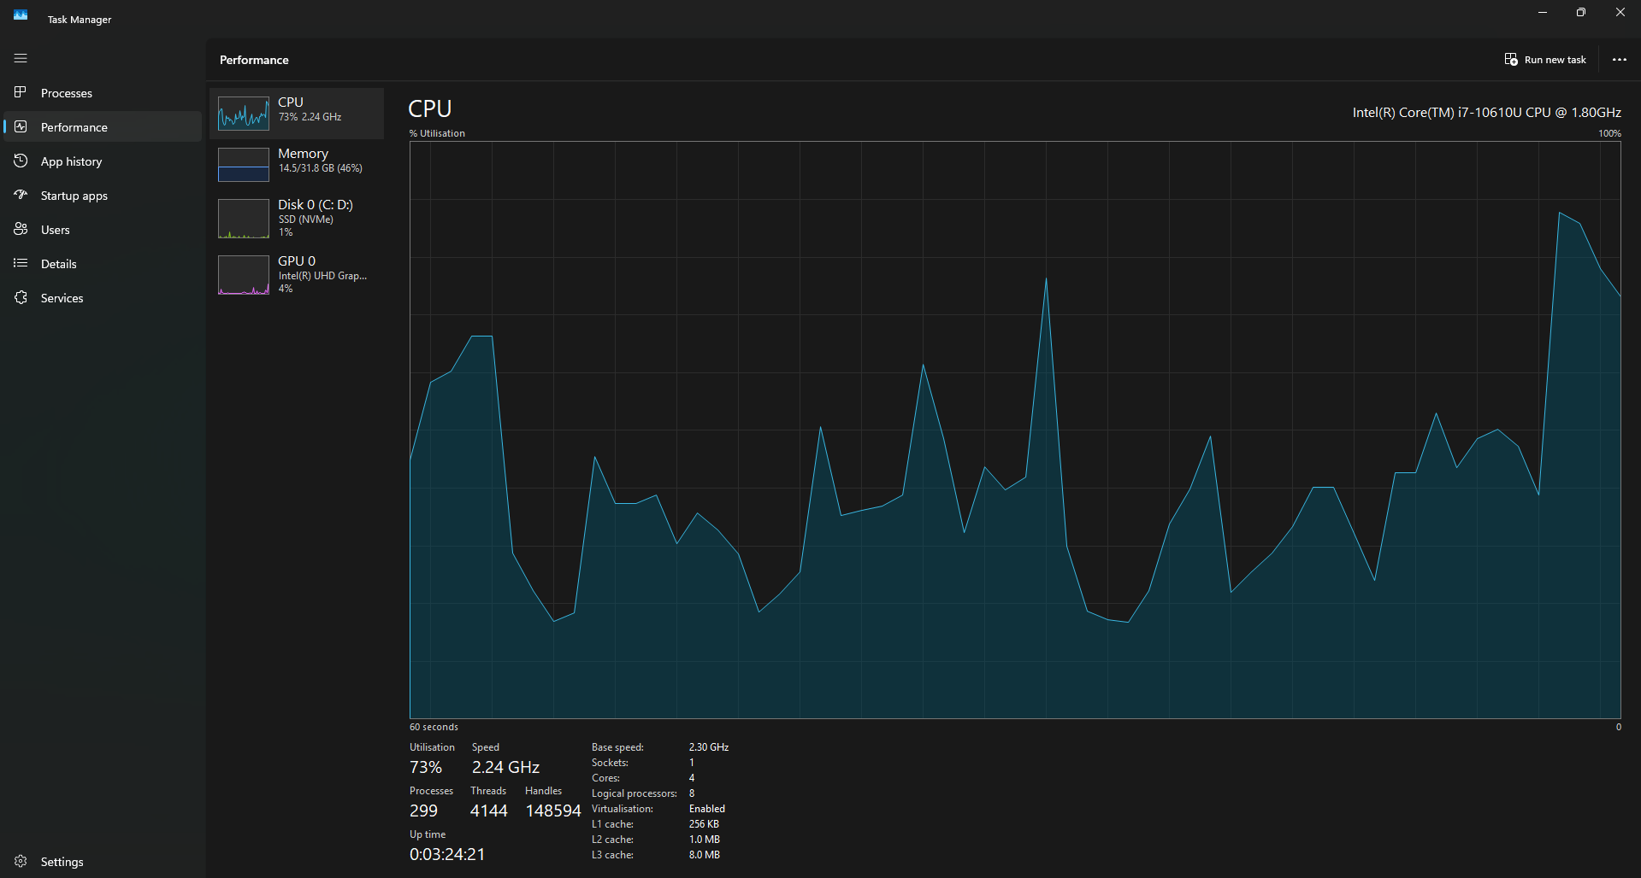
Figure 3: Performance tab Analysis - CPU Graph
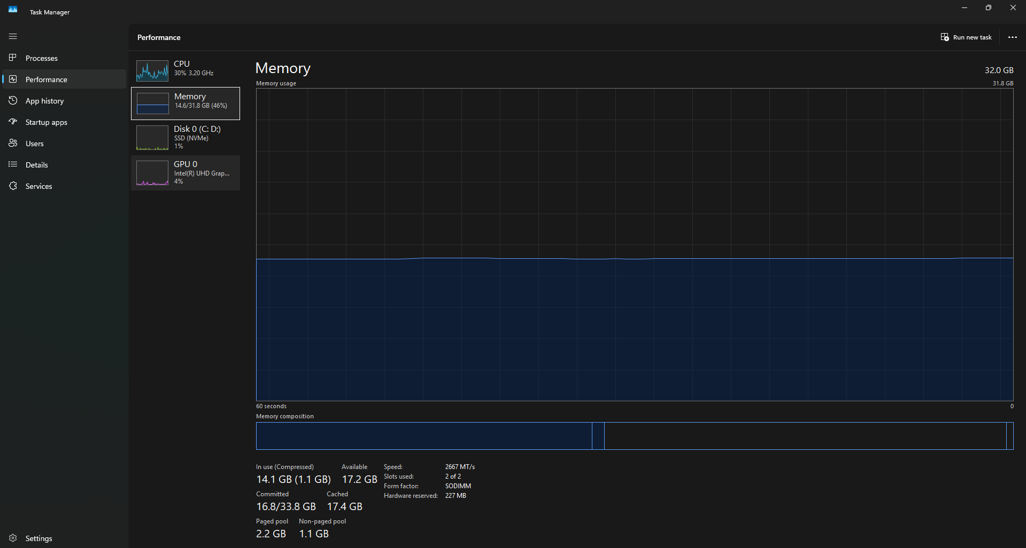
Figure 4: Performance Tab Analysis - Memory Graph

3.4 App History Tab
The App History tab records the cumulative resource usage of applications over time. The data includes CPU time, Network usage, and Metered network data primarily for Microsoft Store applications.
This tab assists in identifying long-term resource-intensive applications and monitoring network usage trends since the last data reset.
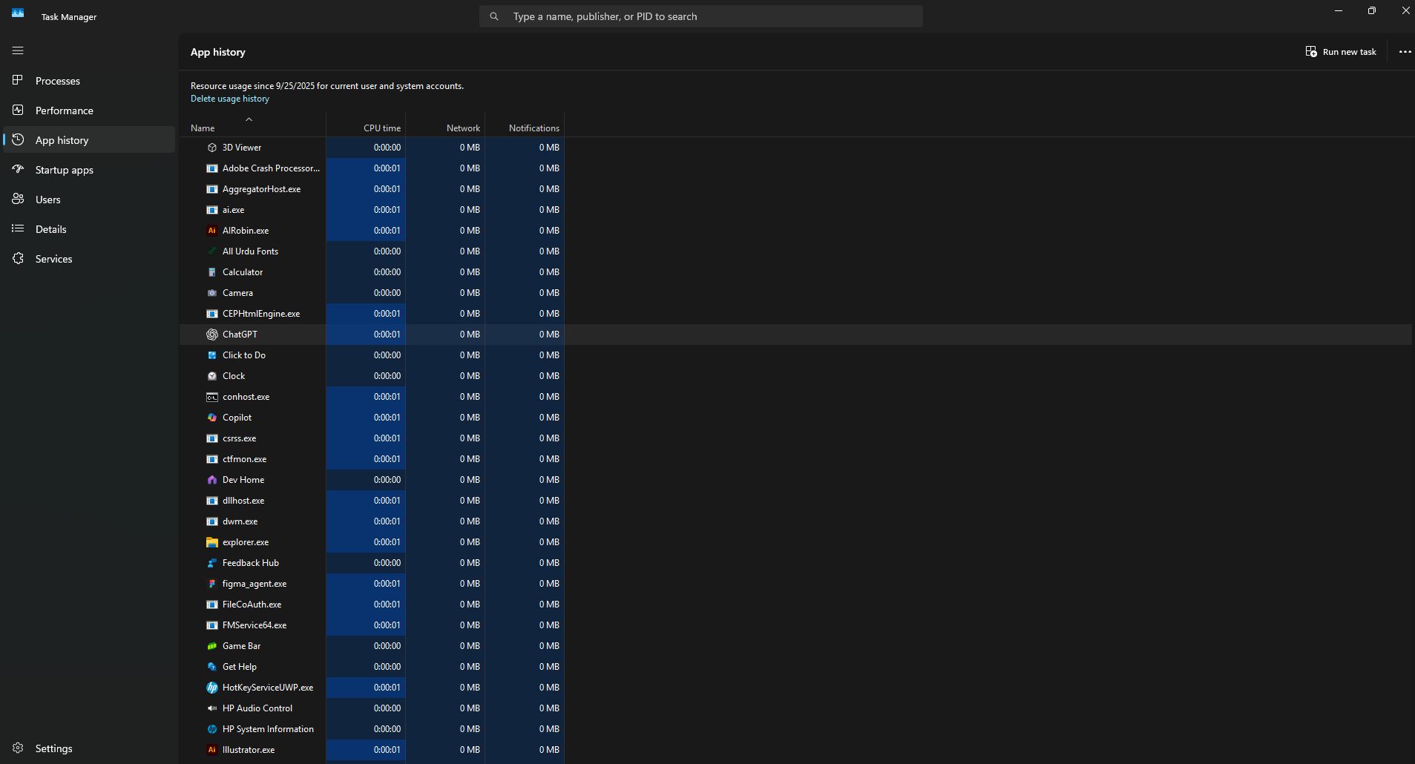
Figure 5: App History Tab Analysis

3.5 Startup Apps Tab
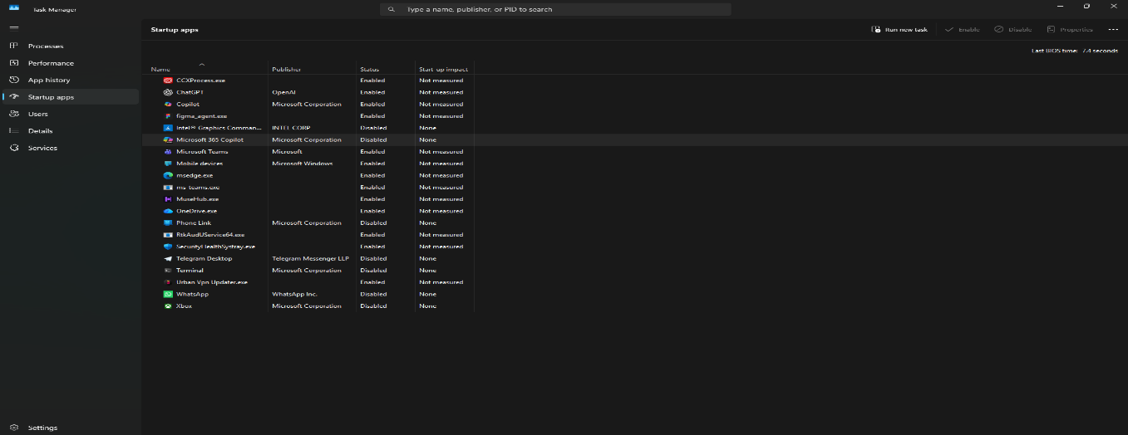
The Startup Apps tab lists all applications configured to launch automatically during system startup. It displays each application’s Publisher, Status (Enabled or Disabled), and Startup Impact level (Low, Medium, or High).
Figure 6: Startup Apps Tab Analysis
By right-clicking on any entry, users can enable or disable its startup behavior, allowing optimization of the boot process and improved system responsiveness.

3.6 Users Tab
The Users tab displays currently logged-in accounts and their associated resource utilization, including CPU, Memory, Disk, and Network usage.
Administrators can manage user sessions through this tab by disconnecting or signing out selected users. This feature is valuable for systems with multiple concurrent logins or shared administrative environments.
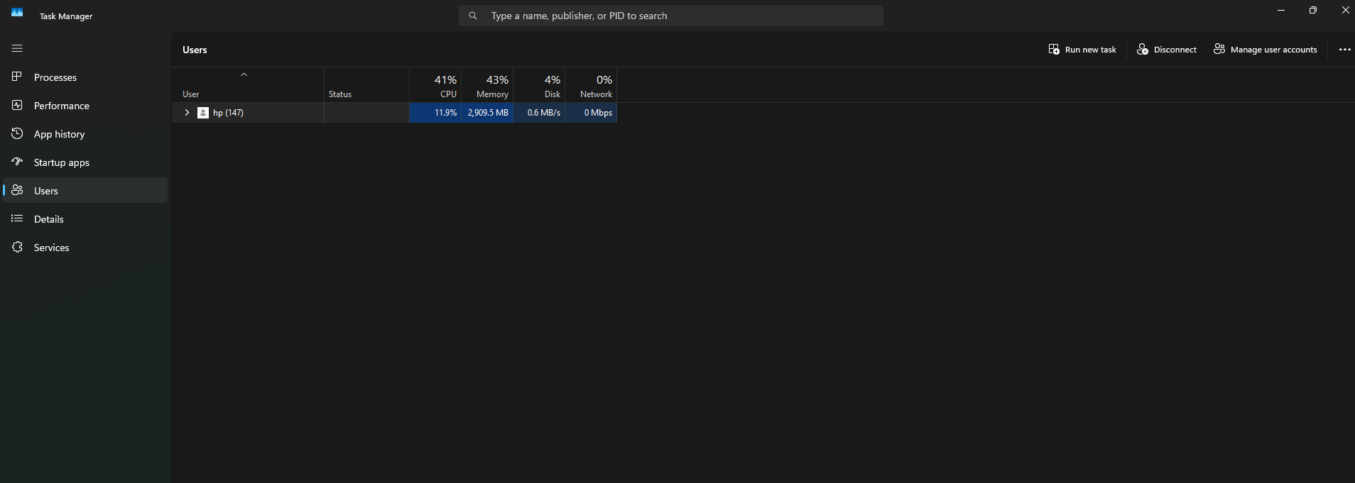
Figure 7: User Tab Analysis

3.7 Details Tab
The Details tab provides a comprehensive view of all running processes, offering fine-grained control and diagnostic capabilities.
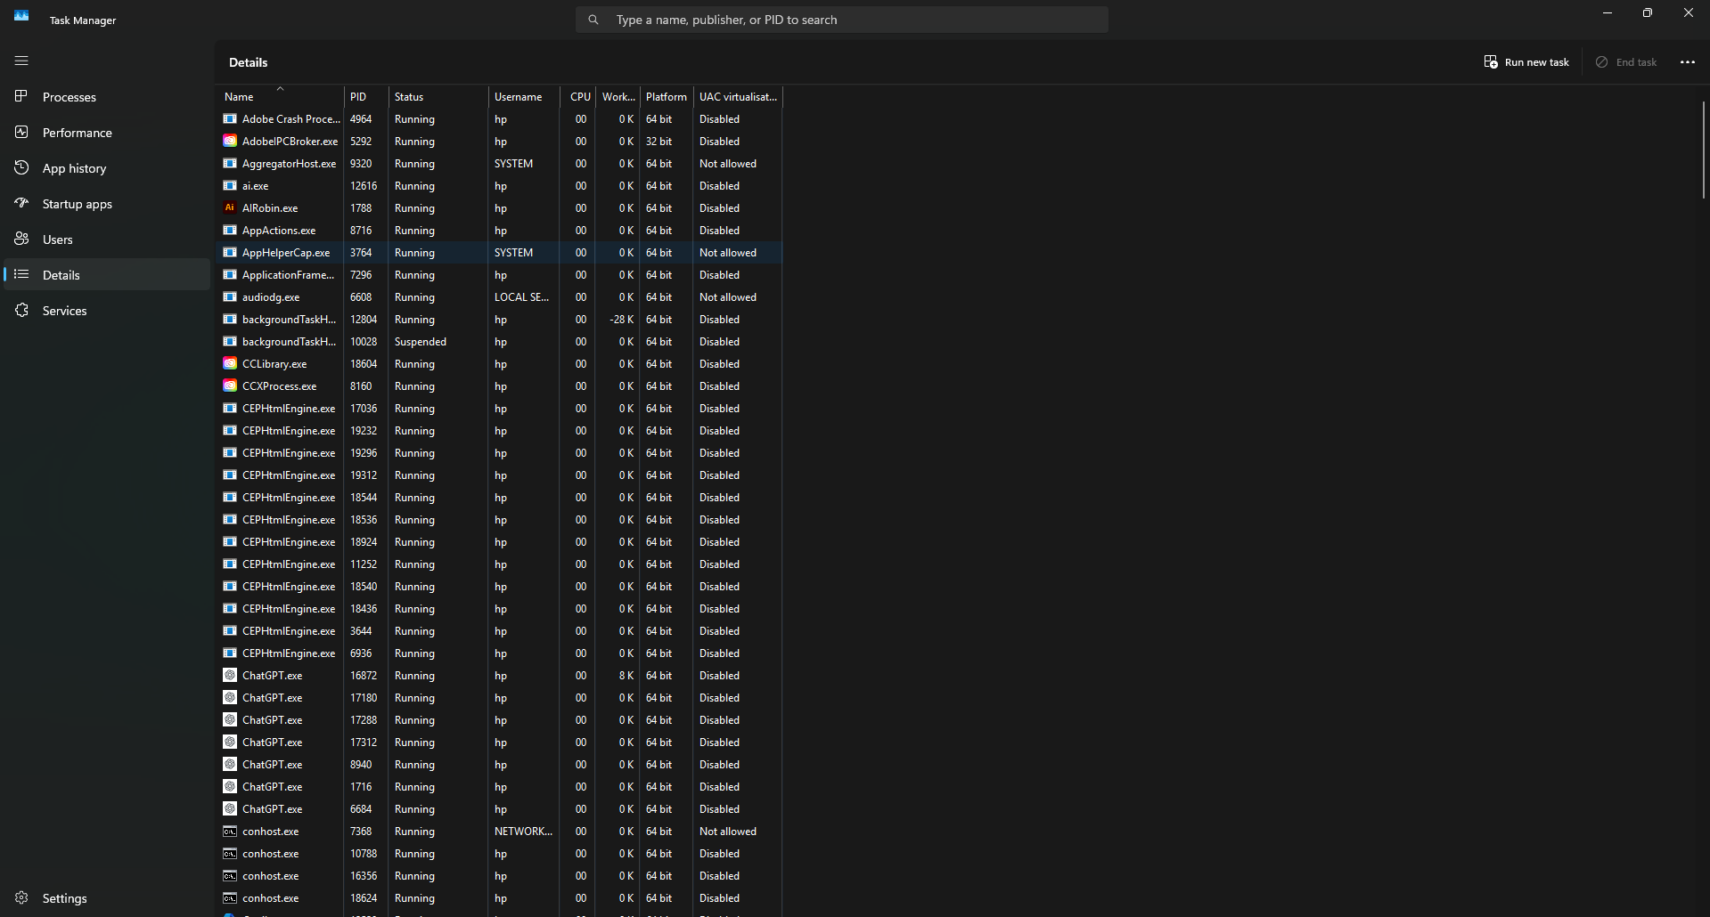

Figure 8: Details Tab Analysis
Information such as Process ID (PID), Status, User Name, CPU, and Memory usage is displayed. Through the right-click context menu, users can set process priorities, define processor affinity, or terminate specific tasks.
This section is primarily used for administrative-level troubleshooting and advanced performance management.

3.8 Services Tab
The Services tab lists all Windows services along with their current operational status — either Running or Stopped. It also displays the PID of each service, linking it to corresponding entries in the Details tab.
The Open Services button at the bottom provides access to the traditional Services Management Console for deeper configuration and control.
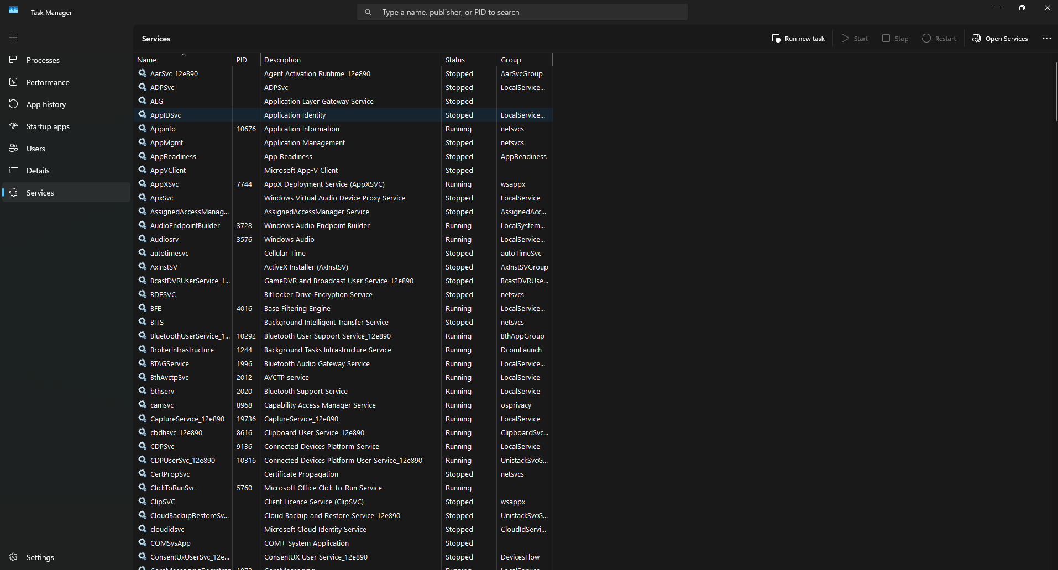
Figure 9: Services Tab Analysis

4. Analysis
The Task Manager provides a comprehensive framework for monitoring and managing system performance. Each tab contributes distinct functionality to the overall system management process:

Tab Name | Primary Function
Processes | Displays real-time application and process resource usage
Performance | Visualizes hardware performance metrics
App History | Maintains historical application usage data
Startup Apps | Controls programs launched during system startup
Users | Monitors resource usage by each logged-in user
Details | Provides advanced control and detailed process data
Services | Manages and monitors background Windows services

Collectively, these components allow users to identify performance bottlenecks, troubleshoot issues, and maintain system stability efficiently.

5. Conclusion
This lab exercise successfully demonstrated the use and importance of the Windows Task Manager as a performance monitoring and management tool. Each tab was examined to understand its role in providing operational insight into processes, resource consumption, and system services.
The analysis confirmed that Task Manager is not only a monitoring utility but also a control interface enabling administrators and users to optimize performance, manage startup configurations, and maintain overall system health.

6. Reflection
Through this practical session, a deeper understanding was developed regarding the interaction between software processes and system hardware. The structured observation of Task Manager’s components reinforced theoretical knowledge of operating system behavior and resource allocation.
Overall, this lab served as a bridge between theoretical system concepts and their real-world application in performance monitoring and system administration.

